PAPER & Axel Obiger Present:
Objects
Louise Bristow / Louisa Chambers / Lisa Denyer / Caitlin Griffiths / David Hancock / Peter Hock / Jeffrey Knopf & Angela Tait / Merja Kokkonen / Gabriele Künne / Niina Lehtonen Braun / Matthew Macaulay / Maja Rohwetter / Ruby Tingle / Hannah Wooll
Exhibition dates: 31 March – 29 April 2023
Private View: Friday 31st March 2023, 7-10pm

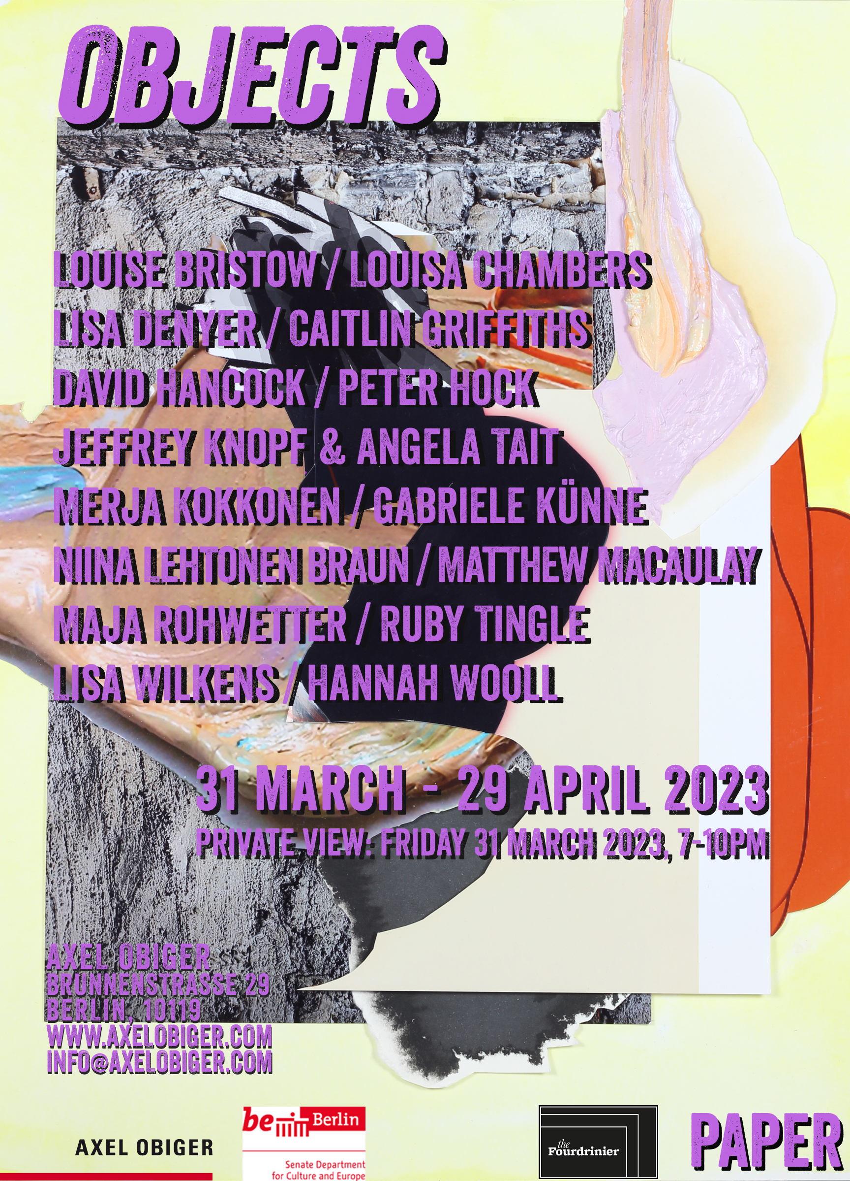
Axel Obiger, working in collaboration with PAPER will draw together the practices of 14 artists working in both Berlin and the United Kingdom. Each artist attempts to disrupt the notion of still life, and reinterpret this genre of art. Still Life was considered the lowest genre of art, and yet in the composition of objects, artists can imply a great deal. Frances Morris wrote of Picasso's still lives, they are "capable of evoking the most complex blend of pathos and defiance, of despair to hope, balancing personal and universal experience in an expression of extraordinary emotional power. The hardship of daily life, the fragility of human existence and the threat of death. These themes permeate through the genre where they remain ever present to this day, simmering below the surface.

In the heyday of Dutch still lives, craftsmanship was crucial. Objects were arranged with precision, emphasising light and shadow, in order to create a compositional tension. Each object was selected for its symbolic meaning, highlighted through the drama of the composition. Observers marvelled at the Trompe l'oeil effect, freezing the objects in time; a study of death. Peter Hock's charcoal drawings make use of these qualities from still life painting, taking them to extremes of chiaroscuro. Light falls on an object rendered in monochrome, depicted by Hock as “abstract realism”. Merja Kokkonen is interested in nature, bodies and their movement, birth, death, and religious practice. If figurative vanitas still lives of the early modern era remind us of the ephemerality of pleasure and the inevitability of death, then medieval saint’s relics offer us much more direct interactions with once-living matter. The very physicality of the preserved body, defying time and decay, can be seen as a reminder of the miracle of existence, a memento nasci (remember that you must be born).

David Hancock's paintings fluctuate between the subject and object. Painted meticulously from a still life diorama, they incorporate lives of Surrealist artists drawn from Hancock’s interpretation of their work. In his staged sets, they become avatars to inhabit and experience the real and imagined world of the artist’s studio. For Louise Bristow, one of the pleasures of making is the juxtaposition of objects that in reality would not be found in the same time or space. She accentuates the mismatch of scale and a collision of visual languages in the set-ups: she will place a realistic three-dimensional architectural model next to a flat image of a landscape, an abstract geometric form and a scrap of coloured paper. To her everything is simply ‘material’ and there is a democracy to how she treats everything.
Caitlin Griffiths explores the relationship between reality and individual identity, drawing on photography's means to observe and document place, people and performance. Her still lives pairing an unopened box and with an open box references Schrödinger’s Cat thought experiment. Reality is only summoned into existence through the act of observing it. Hannah Wooll employs found images from books and objects found in charity shops. She transforms these items into a self contained still life, repurposes them with her cast of lost girls. Niina Lehtonen Braun uses collaged items: alcohol bottles, flowers, clocks, cakes, coffee-cups, cigarettes, laundry etc. These objects have a certain domestic resonance. They suggest the passing of the time? The passing of a life? Her still lives are an opportunity to reflect on death; a momento mori. Similarly, Lisa Wilkens will show Objects of Solace, a series of pencil and watercolour drawings that mark a time in her artistic practice where drawing became a tool to immerse oneself in details and textures during time of grief.
Lisa Denyer creates mixed-media paintings that toy with the idea of their function as object, shifting between the two-dimensional and three-dimensional, they are neither wholly painting or sculpture. Louisa Chambers’ recent work responds to the idiosyncrasies in architecture (ornamentation, pattern, shape, surface and structure). Appropriated patterns from walls, fences, floors are translated onto architectural paper and transfigured into a temporary three-dimensional structure. These forms are recorded from observation becoming an abstracted still life. She is interested in the patterned tessellations that are on the surface of these forms and when manipulated create other spaces, angles and areas of illusion. Matthew Macaulay’s paintings have been developed through observations and experience of objects. The formal elements of objects, such as texture, pattern and colour, are extracted and combined within the works. The paintings attempt to capture the elusive nature of the natural world by transforming and cloaking elements through the creation of painterly signs, drawn from a large still life constructed from a mixture of artworks and other objects from the studio.

Jeffrey Knopf defamiliarises objects – often relics from museum collections – and represents them through incongruous contemporary materials. Angela Tait works primarily with clay and the formal qualities of the vessel. She is interested in the material and conceptual overlaps between domesticity and a creative practice. Together these artists present a collection of individual and collaborative works that explore the interplay between materials, creating propositions and extraordinary new narratives. For Gabriele Künne, abstract objects and object systems, whose indeterminate and indeterminable forms develop out of urban experience, play an essential role in her sculptural work. Künne presents objects made of papier-mâché that contain the glut of daily information contained within the pulp of news, fragmented and legible.

Ruby Tingle's recent works blur the line between object and image; the imagined textures of her paper cut-outs inform a new three dimensional situation in which the collages now exist, their landscapes flitting between pictorial space and fragments of mythical skin. Maja Rohwetter follows a structured conceptual approach to painting that includes the diffuse and the rational, questioning the variables in construction of a picture and representations of reality. As objects are arranged and composed in the classical still life, Rohwetter arranges the picture elements of her collages. The act of arranging and composing is essential and always visible, the picture is a snapshot of a temporary condition. A still.

About Axel Obiger
The project-space, Axel Obiger is an artwork itself, questioning models and mechanisms of the art system. Axel Obiger is comprised of artists: Alke Brinkmann, Thilo Droste, Juliane Duda, Nathalie Grenzhaeuser, Harriet Groß, Gabriele Künne, Matthias Moravek, Enrico Niemann and Maja Rohwetter.

Axel Obiger is a space for contemporary art in Berlin-Mitte. Since its foundation in 2009, it has been promoting two-person and thematic exhibitions to promote a dialogue between the nine permanent gallery artists and invited guest artists and curators. Axel Obiger sees itself as a platform for socially relevant questions that are expressed in increasingly sophisticated artistic ideas and positions.

Axel Obiger not only creates a contact point for Berlin-based and international artistic positions, but also a place for intensive artistic discussion. The exhibitions take place on a monthly basis and are accompanied by lectures, performances, and screenings. Axel Obiger receives the Award for Artistic Project Rooms from the Berlin Senate for Culture and Europe, as well as funding from VG BildKunst and Berlin Senate.

About PAPER

PAPER is an artist-led, commercial gallery based in Manchester and represents a range of emerging and mid-career artists whose practice is based around the medium of paper. Directed by artist David Hancock, working alongside Jo Manby, Lubna Ali, Lisa Denyer, and Simon Woolham, PAPER has participated in numerous national and international art fairs and regularly collaborates with other galleries and project spaces. PAPER recently launched an online contemporary art magazine focusing on art on paper, the Fourdrinier (www.thefourdrinier.com).

